Q1. Construct the decision tree for the following dataset.

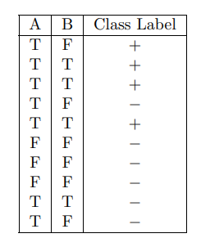

1. Calculate entropy of the given dataset i.e. overall entropy before splitting (wr.to class label)
2. Identify the root attribute
3. Draw the decision tree

Using Gini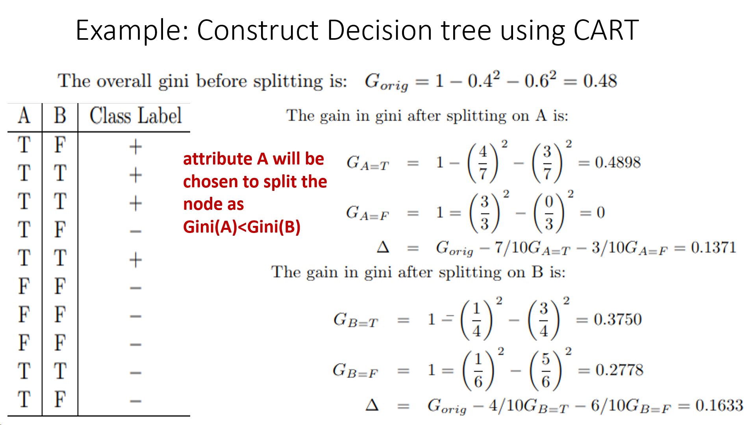

Using ID3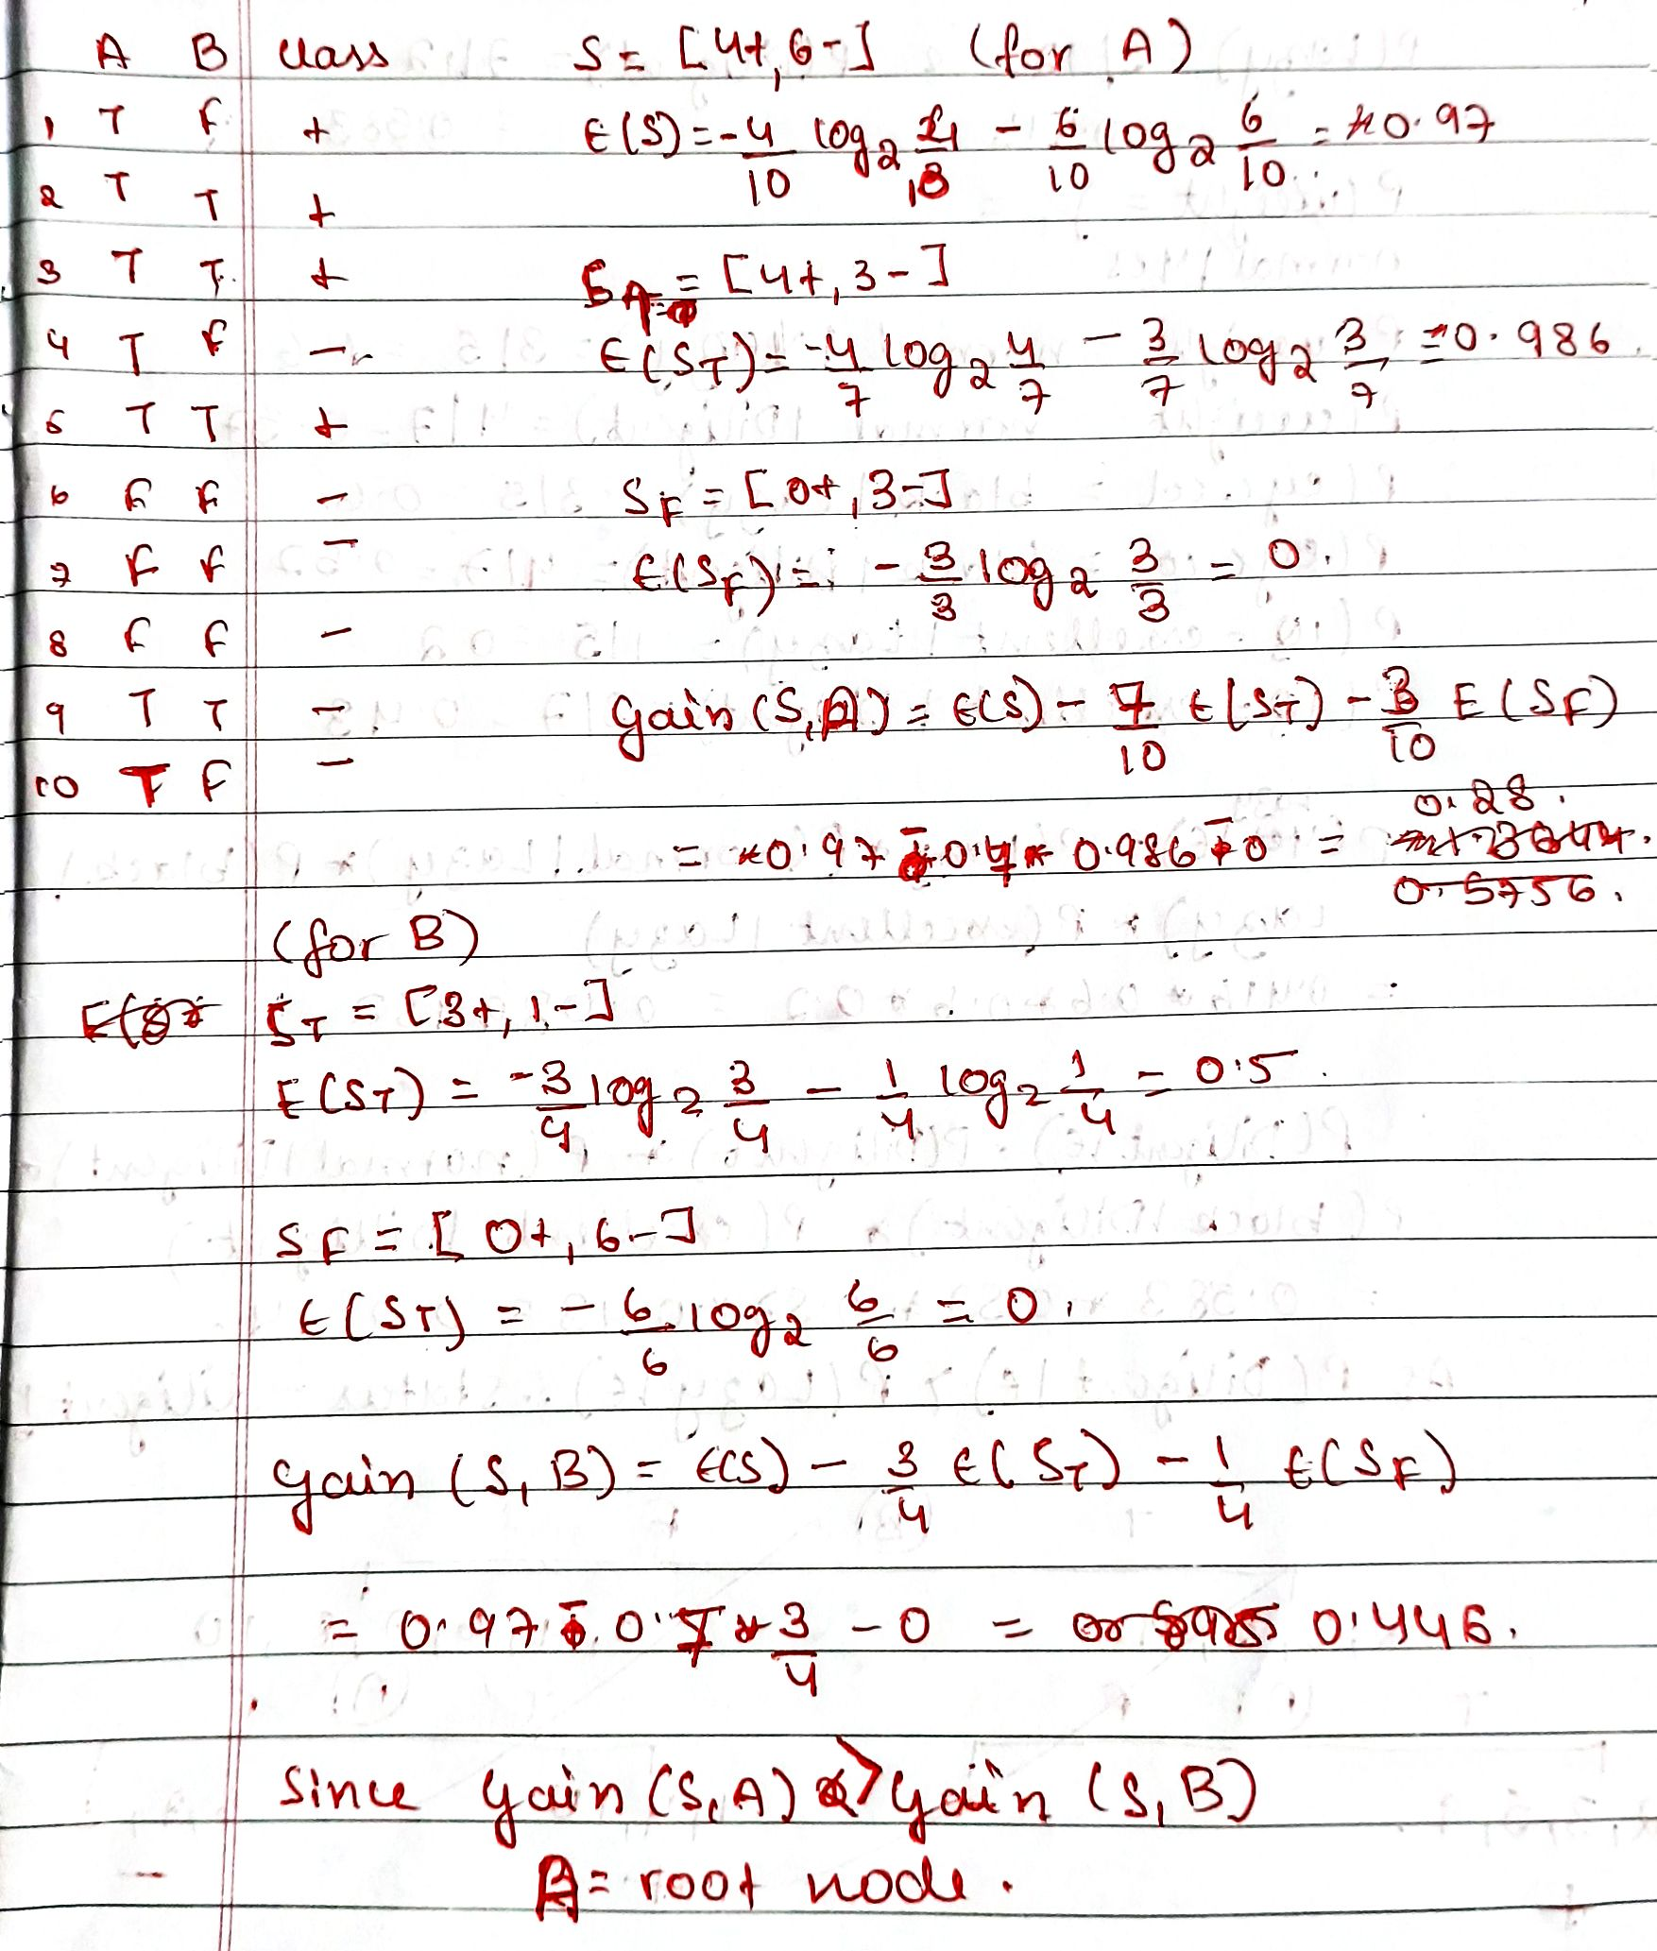

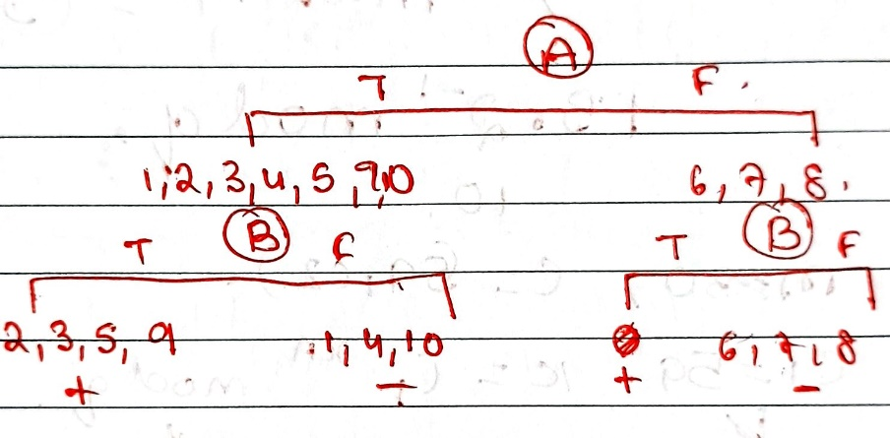

Q2.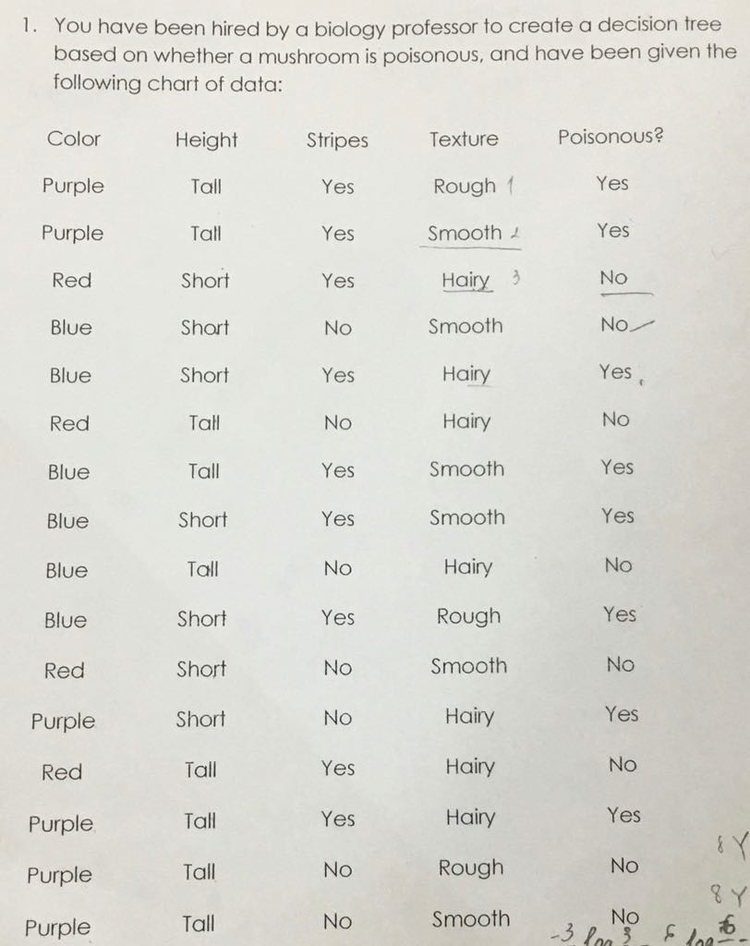

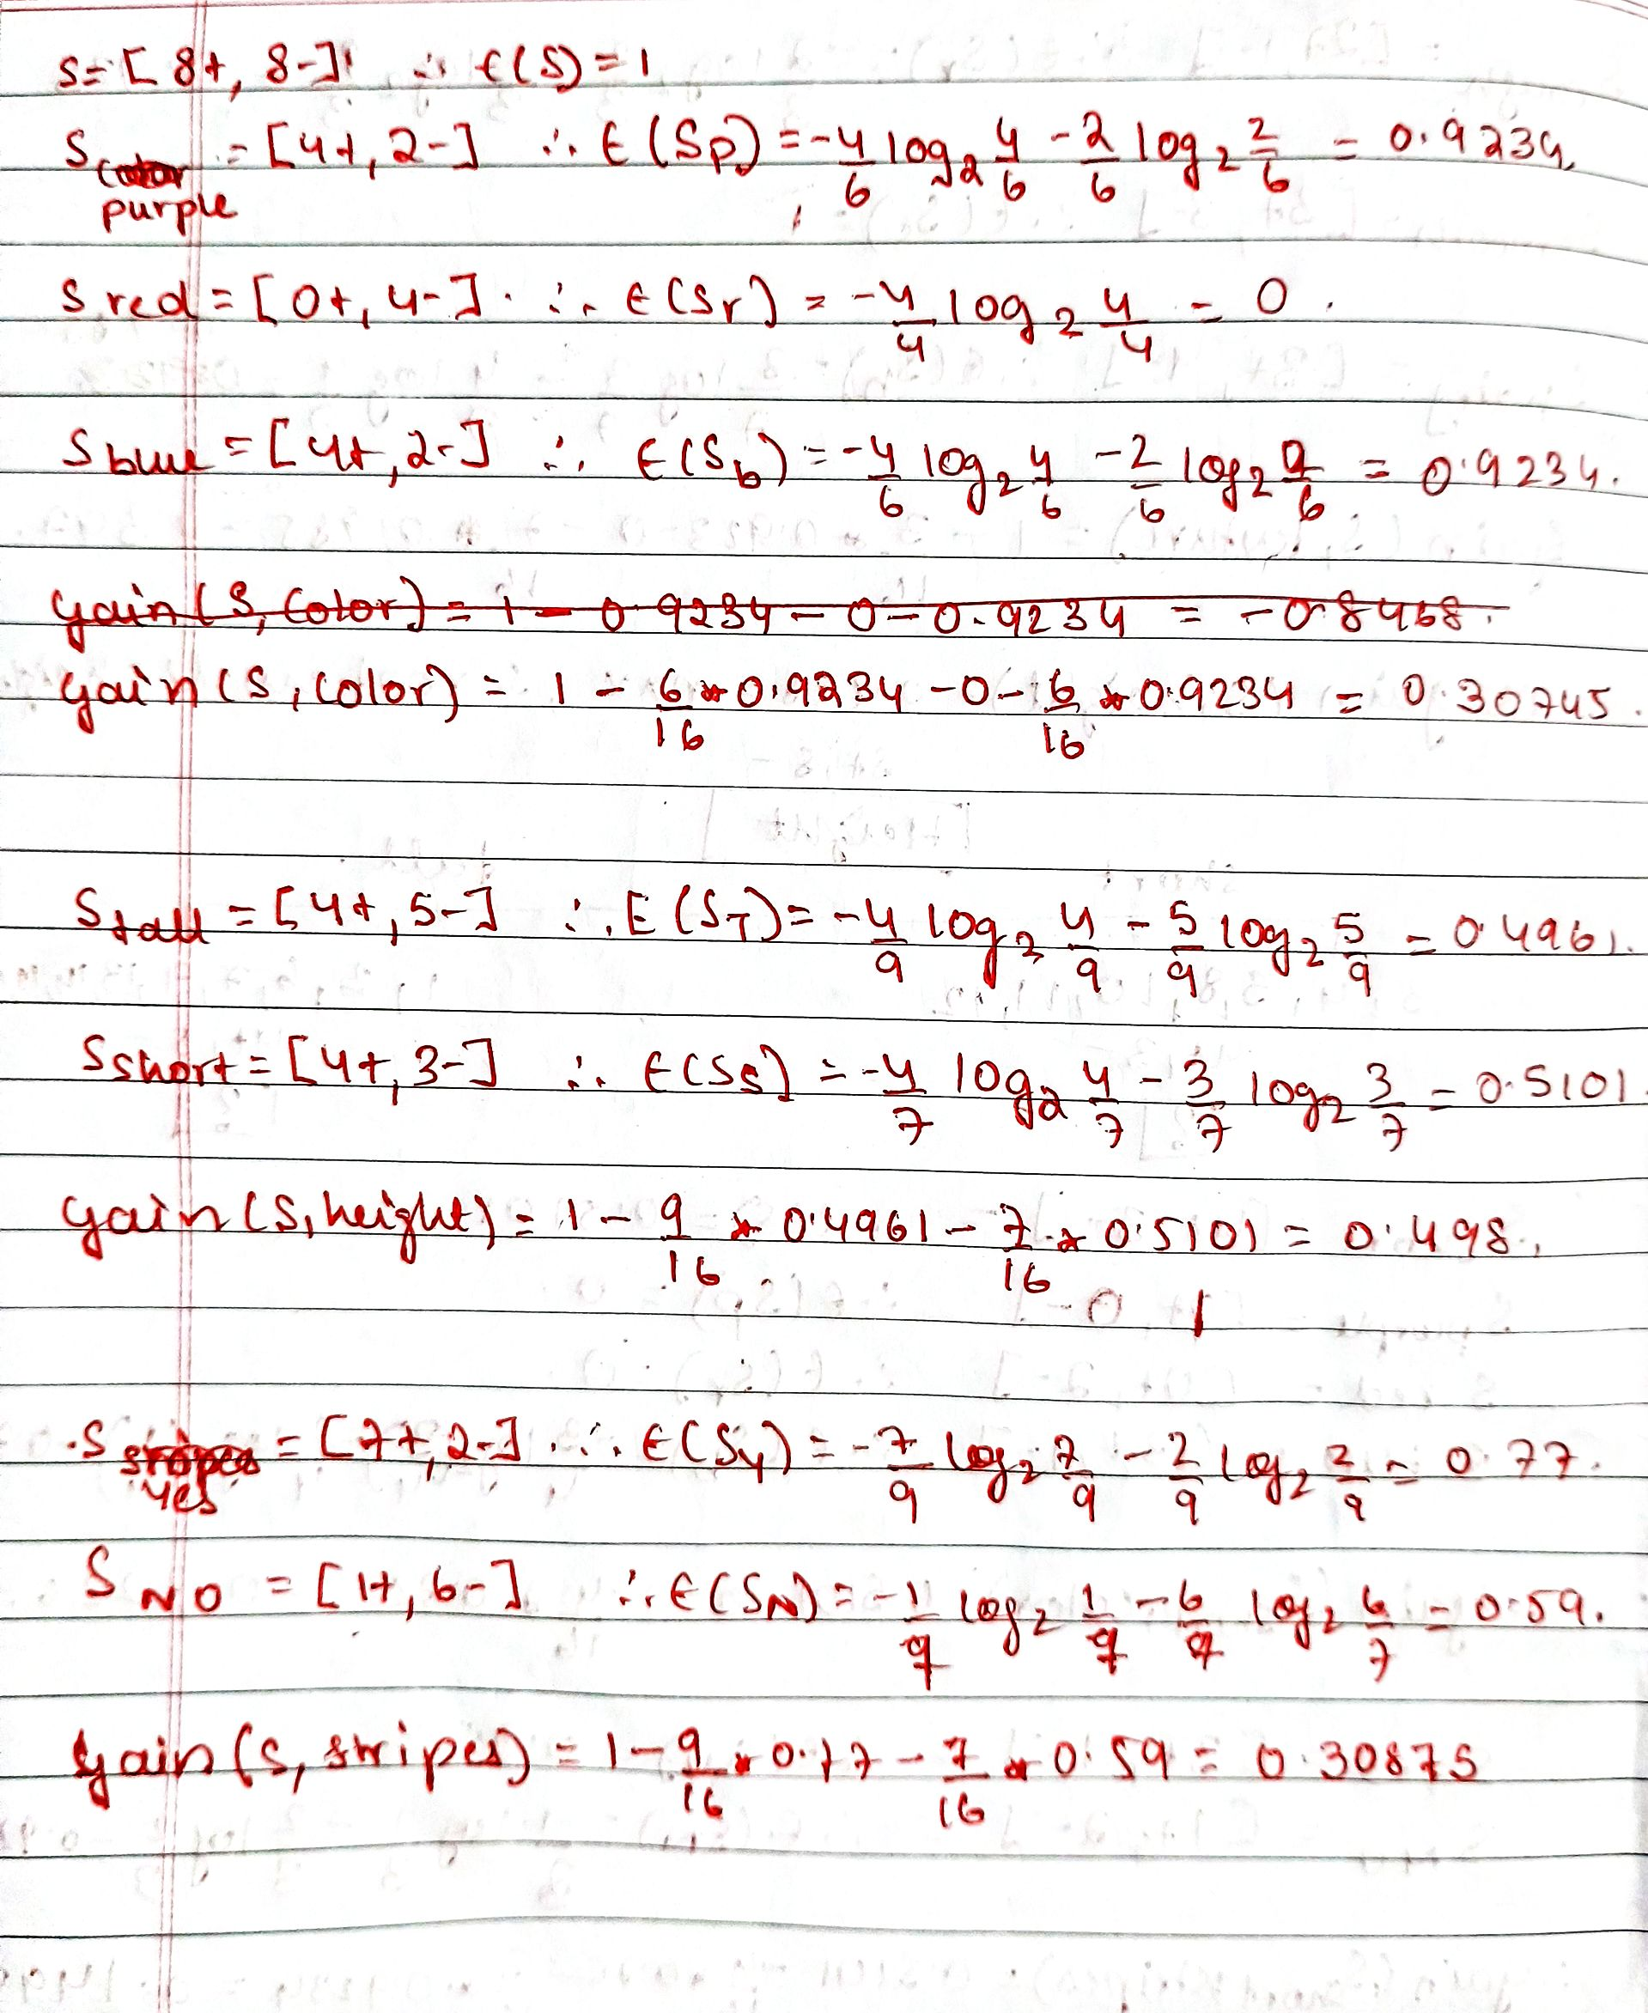

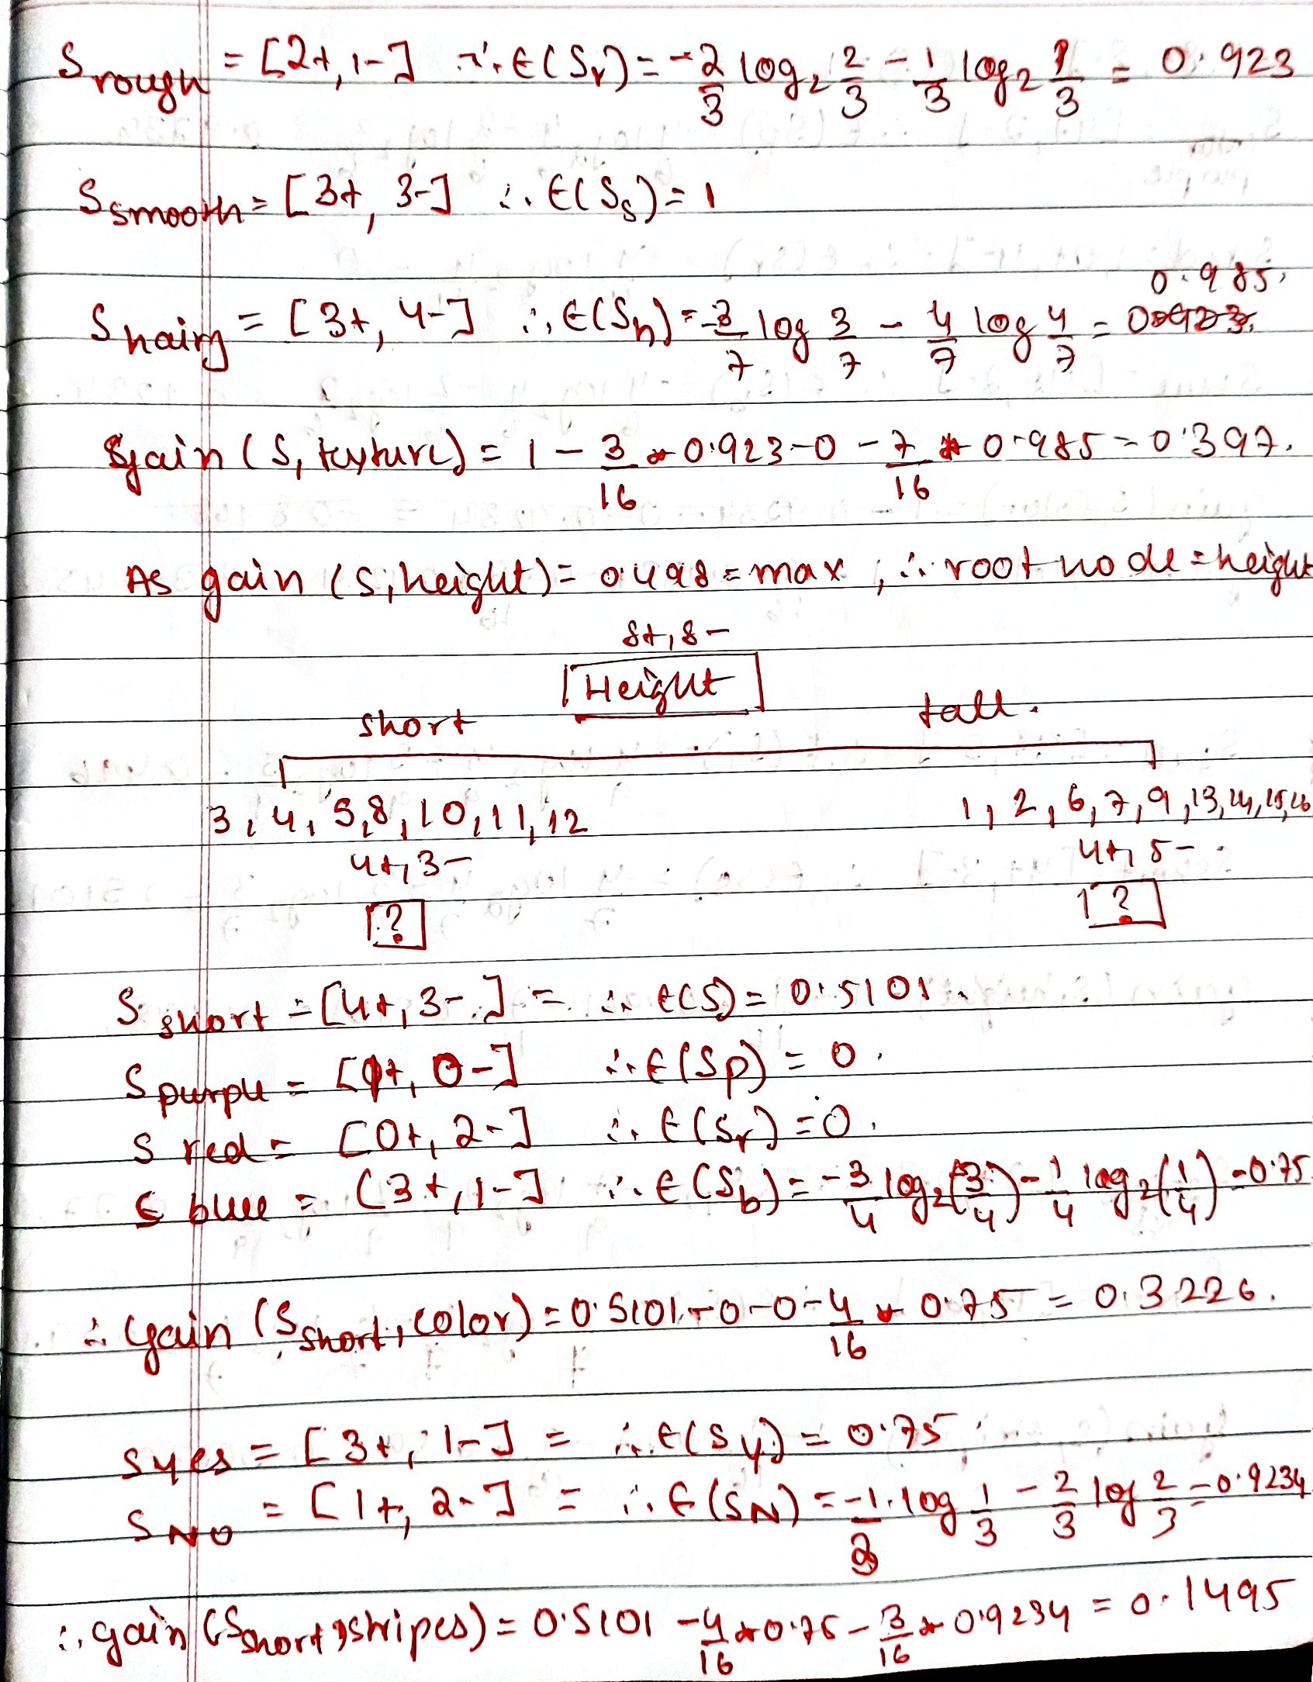 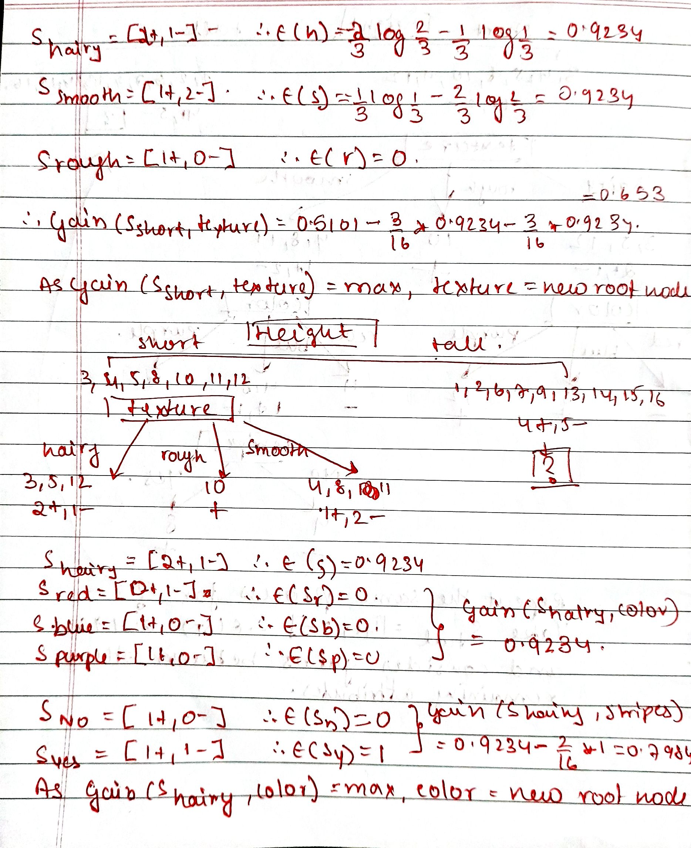

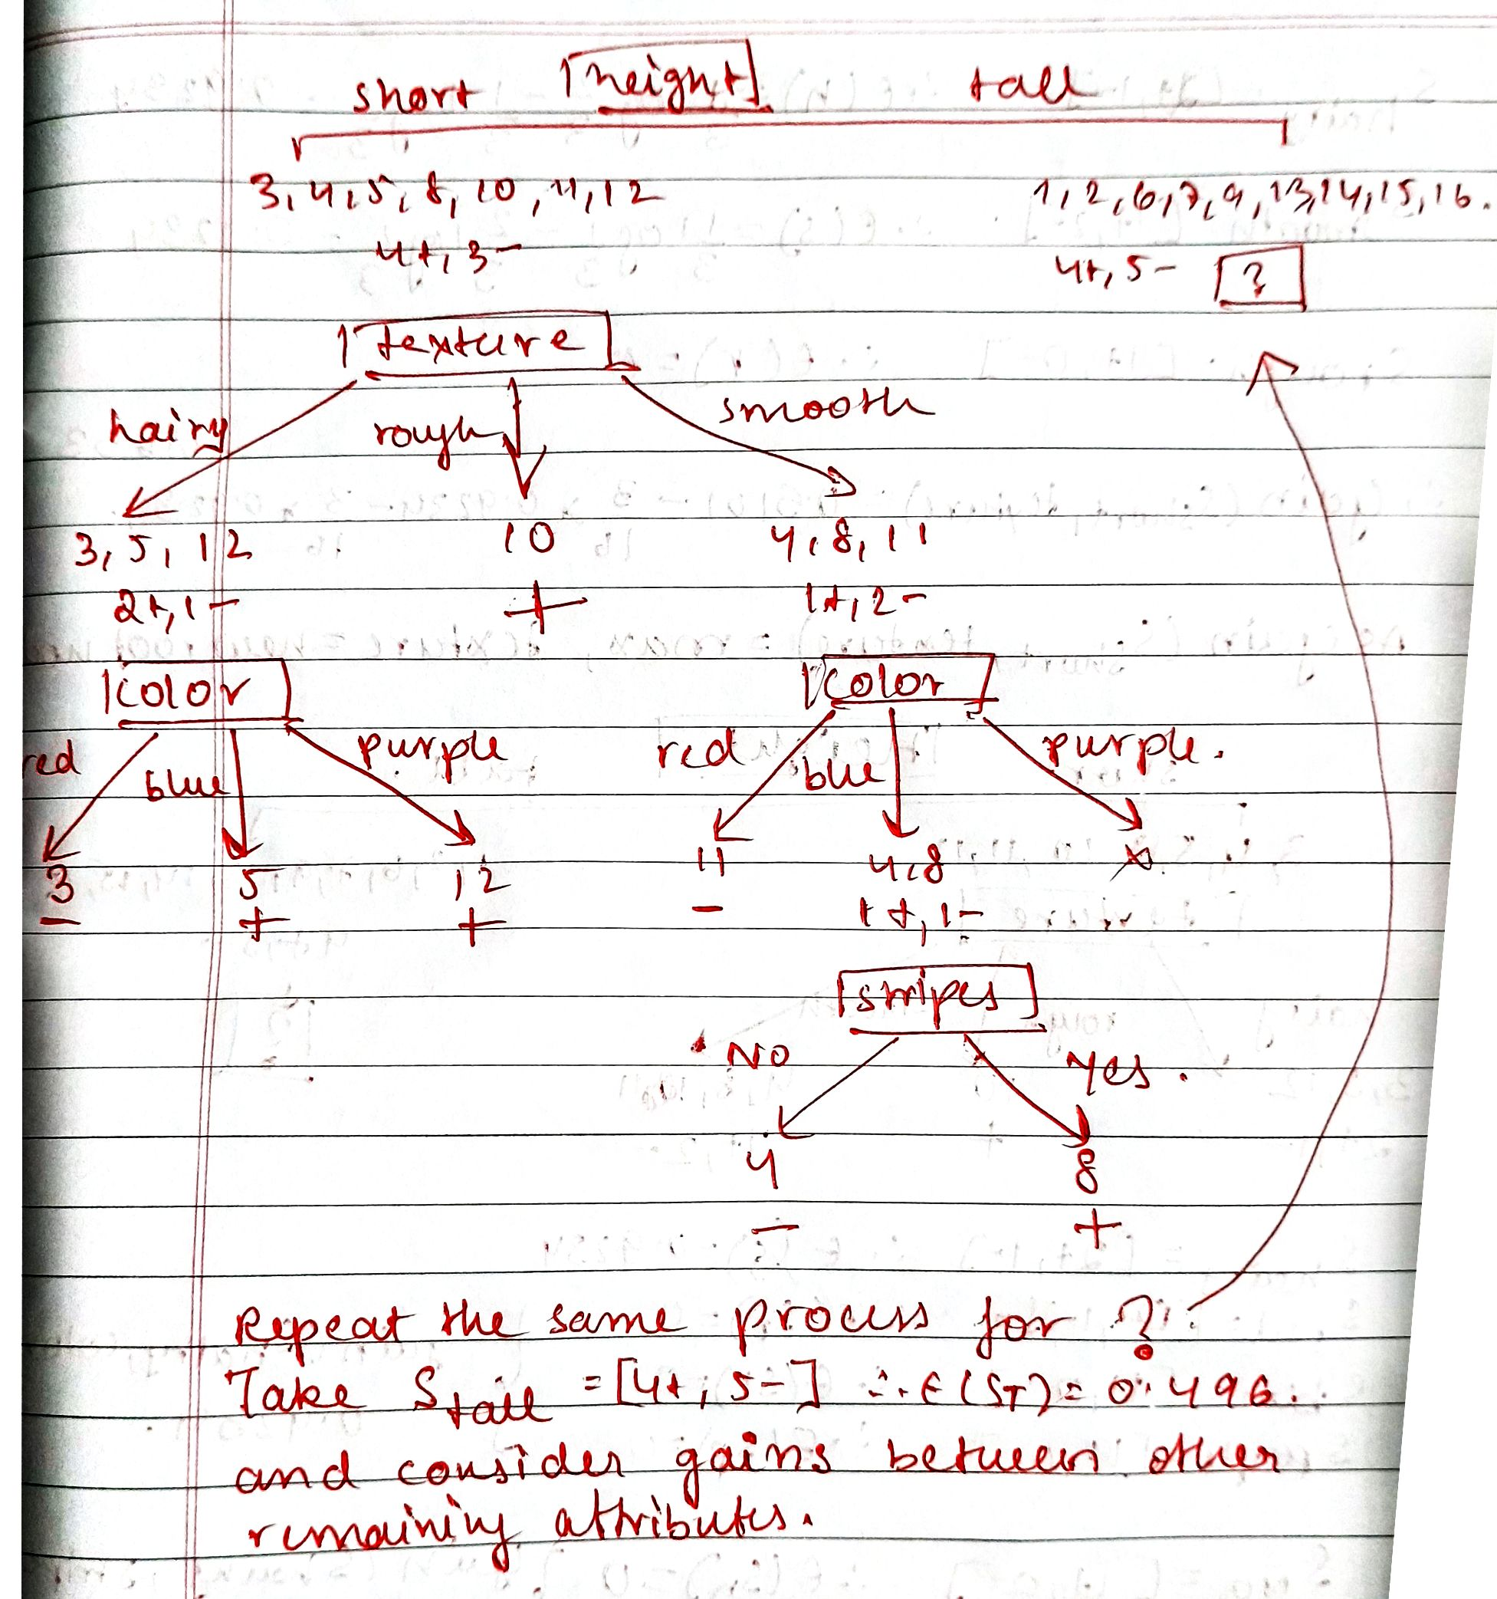

Q3. Consider the following training dataset for predicting whether a Car will be stolen or not.

|  |  |  |  |  |
| --- | --- | --- | --- | --- |
| Sno | Color | Type | Origin | Stolen? |
| 1 | Red | Sports | Domestic | Yes |
| 2 | Yellow | Sports | Domestic | No |
| 3 | Yellow | SUV | Imported | No |
| 4 | Red | Sports | Imported | Yes |
| 5 | Yellow | SUV | Imported | Yes |
| 6 | Red | SUV | Domestic | Yes |
| 7 | Red | Sports | Imported | No |

Using ID3 algorithm and entropy measure, decide the node for split at root level of the decision tree.

Compute Information gain for the attribute Color.

